Thankyou
Wednesday 7 August 2019

2001

POWLETT RIVER PRIMARY SCHOOL
9 – 21 Bent St. Dalyston 3992 ph: 5678 7240

Newsletter
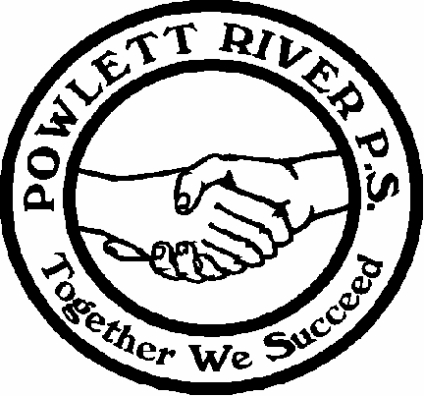

2019 Calendar
TUE Aug 20 | School Council Meeting
Fri Aug 23 | Dress up for Book Week
Sun Oct 20th | Art Show 11 – 3pm
#Permission note and/or payment required

From the Principal

School Council Meeting
postponed to TUESDAY 20th August

Outstanding School Fees and
Camp Manyung – 4-6th Dec
Camp fees will need to be paid in full by Friday 22nd November.
Full payment or instalments for camp and school fees can be made at any time.
Thank you to families who are continuing with their payments.

Justin Curry, Principal

**STARS OF THE WEEK**
Students of the Week

BRANDON
MAGGIE
RHYS

Good Behaviour Raffle Tickets
Ava, Will P, Harvey, Bill, Noah, Jaycob

Yahoo, let’s celebrate books!
We invite everyone to dress up on MARC library day for book week.
Powlett River Primary School
dress up for book week
will be Friday 23rd August.
Who’s your favourite book character and what is their secret power? Start planning now!

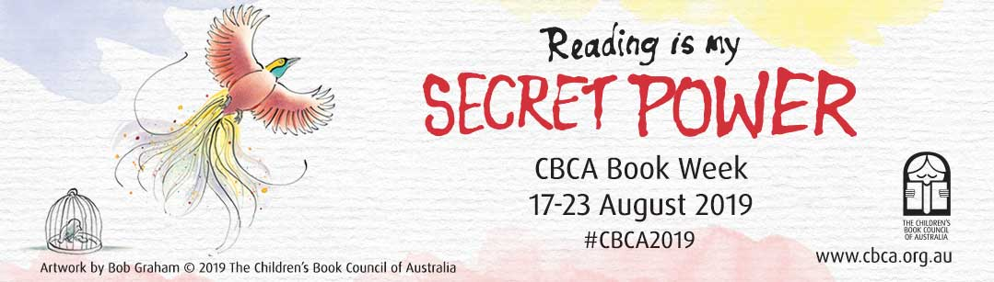

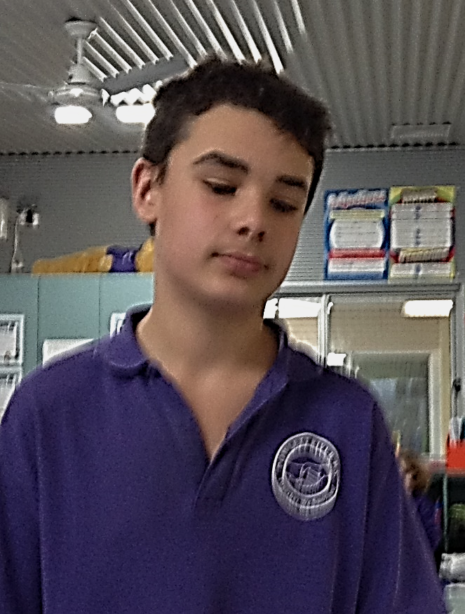
Student Profile
Name: Jethro
Grade: six
Favourite Subject: STEM
Favourite Food: Souvlaki
Favourite TV Show: Don’t remember the last time I watched TV
Favourite Online Game: GTA
Favourite Book:
Wimpy Kids Series
What do you do for fun? Snorkling
What do you want to be when you grow up? Travel
Favourite Holiday Spot: Queensland
Tell me one interesting thing about your Mum: She has to drive, gets stressed when my sister drives

Student Profile
Name: Brodie
Grade: six
Favourite Subject: Science
Favourite Food: KFC
Favourite TV Show: Don’t remember the last time I watched TV
Favourite Online Game: GTA
Favourite Book:
Guinness Book of World Records
What do you do for fun? Go Karting
What do you want to be when you grow up? Sleep
Favourite Holiday Spot: Queensland
Tell me one interesting thing about your Mum: She does Skate Fit

PLAYGROUP
Every Thursday morning @ 9.30am
Here at school in the
WEST CREEK ROOM
Contact Aida: 0401255852

Winter Health and Hygiene reminder
It is crucial that everyone is careful about:
- coughing/sneezing into elbows,
- using/disposing of tissues,
- washing hands well
- keeping up with personal cleanliness

**Please do not send children to school
if they are unwell**

Healthy Eating – for energy and
to help boost the immune system
Please ensure children have a healthy lunch and snacks to eat at school.

Help Your Child With Learning at Home.
D.E.T. has provided a booklet for parents.
Please check it out.
https://www.education.vic.gov.au/school/parents/involve/Pages/support.aspx

Demystifying Dyslexia in Wonthaggi:
What it is and strategies to help your child
Date: Tuesday 24th Sep, 2019
Time: 6:00 PM - 9:00 PM
Registration Close Date: Tuesday 24th Sep, 2019
Location: Wonthaggi - TBC, Wonthaggi, Victoria, Australia
Member: $25.00 Non-member: $40.00
Please email events@speldvic.org.au if you require any additional information
At this information session, we welcome Parents, Students, Teachers, and Allied Health Professionals,
to increase your understanding of Specific Learning Difficulties such as Dyslexia.

Powlett River Primary School is
a Foodbank School.
Foodbank supports and helps with supplies for our
Breakfast Club –
each THURSDAY
Please let us know if you can volunteer some time to assist.
Recycling – Get the children involved. Hang an empty bread bag near the bin and fill it with your soft plastics ready to take to Coles or Woollies when you shop….
and take used cartridges to a Planet Ark box. There is a box here at school.

